A PROJECT ON

Online Food Ordering System

BY

NAME OF STUDENT
Mr. Shrinath Umakant Mate
&
Mr. Darshan Suresh Chavan

UNDER THE GUIDANCE OF
PROF. YOGESH DESHMUKH

SUBMITTED TO

SAVITRIBAI PHULE PUNE UNIVERSITY



SAVITRIBAI PHULE PUNE UNIVERSITY

IN PARTIAL FULFILLMENT FOR THIRD YEAR OF BACHELOR OF BUSINESS ADMINISTRATION COMPUTER APPLICATION BBA(CA)

BATCH-2024-2025



ALARD COLLEGE OF BUSINESS STUDIES, PUNE

"Online Food Order System"

ALARD COLLEGE OF BUSINESS STUDIES
TY-BBA (CA)

SUBMITTED TO

SAVITRIBAI PHULE PUNE UNIVERSITY

Project Guide : Project By :

Prof. Yogesh Deshmukh Shrinath Umakant Mate

TY BBA(CA)

Academic Year 2024-2025



ALARD COLLGE OF BUSINESS STUDIES Pune-45.
(Bachelor of Computer Application)
CERTIFICATE

Exam Seat No. : Date :

This is to certify by that Mr. __________________________________ has successfully completed the Project titled Online Food Order System for TY BBA (CA) (Sem-V) for the year (2024-2025).

Project Guide: Principal:

_________________________ ________________________

Internal Examiner:- External Examiner:-

______________________ ________________________
Project report of online food order system

Acknowledgement

Online Food Order System is a product of me and my project partner’s hard work and dedication We take this opportunity to express our sincere gratitude towards our project guide Mr. Prof. Yogesh Deshmukh Sir for his valuable guidance given to us by him throughout our project.

We would also like to thank our college teaching staff and working staff for providing us with all lab facilities which made our project work very convenient.

We would also like to express our appreciation and thanks to all our friends who have assisted and encouraged us throughout the work.

Project report of online food order system

Index

Sr. No |  | Particulars | Page No
A |  | Introduction | 5
 | 1 | Title of Project | 6
 | 2 | Existing System | 6
 | 3 | Proposed System | 7
 | 4 | Feasibility Study | 8
 | 5 | Hardware and Software Requirements | 8
 | 6 | Abstract and Objective | 10
B |  | Analysis
 | 1 | ERD | 11
 | 2 | DFD | 12
C |  | Design
 | 1 | Input and Output Screen (With Data) | 12-24
D |  | Code Design | 25-26
E |  | Limitations of System | 27
F |  | Conclusion | 28
G |  | Future Enhancement | 29
H |  | Reference | 30

Project report of online food order system

Title of the Project:

“Online food order system”

Introduction:

The “Online Food Ordering System” is a robust and scalable application, designed to simplify the process of ordering food online. This system is built using Python, and its librarys. using its powerful features and libraries to deliver a seamless and efficient user experience.

The application is reduced as much as possible to avoid the error while entering the data. It also provides error message while entering invalid data. To overcome that problem we are going to develop this proposed system with the help of TKINTER (Part of Python Library) as a Front end and PYTHON as a Back end also for billing.

The Online Food Ordering System aims to streamline the food ordering process by allowing users to browse menus, place orders with a user-friendly web interface. The backend is designed to handle high traffic, manage inventory, and user food order bills making it an ideal solution for restaurants and food delivery services.

Key Features:-

- User Management:

>> Account Creation: Users can login with name and phone number to manage their orders and preferences. also see real time total bill value and Quantity of order.

- Menu Management:

>> Dynamic Menu Display: Restaurant owners can update their menu items and prices in real-time.

>> Categorization: Menus are categorized for easy browsing

Project report of online food order system

Existing System of Project:
1. Manual Ordering System:-
- Phone Orders: Customers call the restaurant to place their orders. The restaurant staff manually takes the order, writes it down, and processes it.
- In-Person Orders: Customers visit the restaurant and place their orders in person. The staff then enters the order details into a system or records it manually.
2. Basic Digital Solutions:-
- Simple Website or Web Form: Some restaurants might have a basic website with a form for placing orders. These forms are often not integrated with the restaurant’s internal systems, leading to manual order processing.
- Email Orders: Customers send their orders via email, and staff manually process these orders.
3. Third-Party Platforms:-
- Food Delivery Aggregators: Restaurants might use third-party services like Zomato, Swiggy, or Blinkit. While these platforms handle order processing and delivery, they often come with high commissions and limited customization for the restaurant.
4. Limited Integration:-
- Separate Systems for Different Functions: Restaurants may have separate systems for handling inventory, customer management, and orders. These systems are not integrated, causing inefficiencies and manual data entry.
5. Customer Feedback and Reviews:-
- Manual Collection: Customer feedback and reviews might be collected manually through comment cards or direct communication, with no systematic way of gathering or analyzing this data.
Challenges with Existing Systems:
- Inefficiency and Error-Prone
- Limited Customer Experience
- High Costs
- Poor Data Management

Project report of online food order system

Proposed System of Project:
.

This online application enables the end users to order online, select the food from the e-menu card, read the E-menu card and order food online. By just selecting the food that the user wants to have.

By using this application, the work of the Waiter is reduced. The benefit of this is that if there is rush in the Restaurant then there will be chances that the waiters will be unavailable and the users can directly order the food to the chef online by using this application. The user will be given a username and a Phone Number.

1. System Architecture

- Web Interface:- Developed using Python web frameworks and frontend technologies.
- Admin Dashboard:- Interface for restaurant management, also built with Python.

2. User Features

- Browse and Search Menu:- View and search for menu items.
- Place Orders:- Add items to the cart, select delivery options, and place orders.
- user interface:- the user interface is very clear and simple to understand, anyone can easily order their favorite food

3. Technology Stack

- Frontend
- Flask/Django:- Web frameworks to create the web interface.
- Tkinter:- This is also python library use as frontend web interface

- Backend
- Flask:- Lightweight Python web framework for handling routes and server-side logic.

Project report of online food order system

Feasibility Study:

Feasibility Study is assessment of the proposed plan. The feasibility study is carried out to select the best system that meets the performance requirements of the system.

Feasibility study includes consideration of the all the possible ways to provide a solution to the given problems. The proposed solution should satisfy all the User requirements and should be flexible enough so that future changes can be easily done based on the upcoming future requirement.

Hardware Requirements:

Processor :- Pentium 2.4GHz or Above

RAM :- Minimum 4GB or Higher

Cache Memory :- 128 KB or Above

Disk Space :- Minimum 20GB

Printer ;- Laser Printer

Software Requirements:

Operating System :- WINDOWS / Linux / Mac

Web Technologies :- Tkinter(Standard Python Library), OS, Time, MessageBox

Technologies :- Python GUI

IDE :- PYCHAM , Visual Studio Code

Browser :- Pycham Web Terminal.

Project report of online food order system

Abstract:

The online food ordering system provides convenience for the customers. It overcomes the disadvantages of the traditional queuing system. This system increases the takeaway of foods than visitors. Therefore, this system enhances the speed and standardization of taking the order from the customer. It provides a better communication platform. the user's details are noted electronically.

The online food ordering system set up menu online and the customers easily places the order with a simple mouse click. This system allows the user to select the desired food items from the displayed menu. The user orders the food items. The user's details are maintained confidential because it maintains a separate account for each user. An Name and Mobile Number are provided for each user. Therefore, it provides a more secured ordering.

Objective:

The main objective of this project is to develop an application which gives provision to the restaurant owners to flourish their business by uploading menus at no cost and will invariably lead to higher customer retention and acquisition rates.

User Friendly: Online Food Ordering System is a very user-friendly project because the Food Ordering Record and searching from categories is very simple, fast and data is secured. The user interface of the project is very simple.
Order reports of the system can be easily generated. User can generate the report of any particular date and period. In this way they can get delivery status of customers and get information about what is being ordered.

Very less paper work: Online Food Ordering System requires less paper work. In this project all record is fetched directly into the computer and reports can be generated through just a click. In this way it saves time. As data is directly entered into computer so there is no need to do any paper work.

Computer operator control: Online Food Ordering System is operated by the staff members and one admin so there is no chance of clerical mistakes. Data feeding and retrieving in this system is very easy. So, the work can be done on time.
Project report of online food order system

ERD

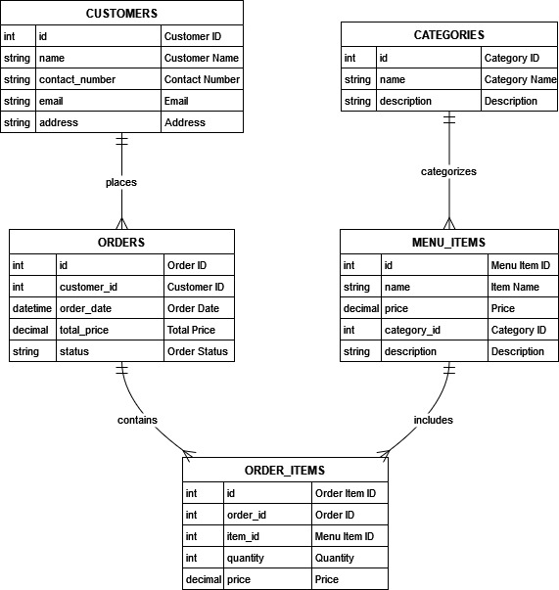

report of online food order system

DFD
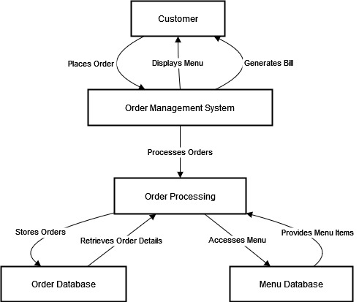

Project report of online food order system

Input Screen and Output Screen (With Data) :

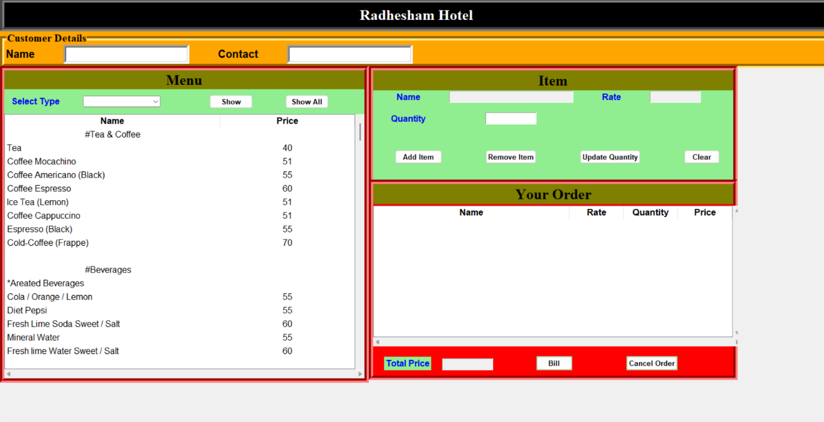

Sample Code(Main.py) :-
#================Frontend Code Start==============
root = Tk()
w, h = root.winfo_screenwidth(), root.winfo_screenheight()
root.geometry("%dx%d+0+0" % (w, h))
root.title("Welcome to Radhesham Hotel")
root.wm_iconbitmap("Burger.ico")
#root.attributes('-fullscreen', True)
#root.resizable(0, 0)
#================Title==============
style_button = ttk.Style()
style_button.configure("TButton",font = ("arial",10,"bold"),
background="lightgreen")

title_frame = Frame(root, bd=8, bg="black", relief=GROOVE)
title_frame.pack(side=TOP, fill="x")

title_label = Label(title_frame, text="Radhesham Hotel",
font=("times new roman", 20, "bold"),bg = "black", fg="white", pady=5)
title_label.pack()

#==============Customer=============
customer_frame = LabelFrame(root,text="Customer Details",font=("times new roman", 15, "bold"),
bd=8, bg="orange", relief=GROOVE)
customer_frame.pack(side=TOP, fill="x")

customer_name_label = Label(customer_frame, text="Name",
font=("arial", 15, "bold"),bg = "orange", fg="black")
customer_name_label.grid(row = 0, column = 0)

customerName = StringVar()
customerName.set("")
customer_name_entry = Entry(customer_frame,width=20,font="arial 15",bd=5,
textvariable=customerName)
customer_name_entry.grid(row = 0, column=1,padx=50)

customer_contact_label = Label(customer_frame, text="Contact",
font=("arial", 15, "bold"),bg = "orange", fg="black")
customer_contact_label.grid(row = 0, column = 2)

customerContact = StringVar()
customerContact.set("")
customer_contact_entry = Entry(customer_frame,width=20,font="arial 15",bd=5,
textvariable=customerContact)
customer_contact_entry.grid(row = 0, column=3,padx=50)

#===============Menu===============
menu_frame = Frame(root,bd=8, bg="red", relief=GROOVE)
menu_frame.place(x=0,y=125,height=585,width=680)

menu_label = Label(menu_frame, text="Menu",
font=("times new roman", 20, "bold"),bg = "Olive", fg="black", pady=0)
menu_label.pack(side=TOP,fill="x")

menu_category_frame = Frame(menu_frame,bg="lightgreen",pady=10)
menu_category_frame.pack(fill="x")

combo_lable = Label(menu_category_frame,text="Select Type",
font=("arial", 12, "bold"),bg = "lightgreen", fg="blue")
combo_lable.grid(row=0,column=0,padx=10)

menuCategory = StringVar()
combo_menu = ttk.Combobox(menu_category_frame,values=menu_category,
textvariable=menuCategory)
combo_menu.grid(row=0,column=1,padx=30)

show_button = ttk.Button(menu_category_frame, text="Show",width=10,
command=show_button_operation)
show_button.grid(row=0,column=2,padx=60)

show_all_button = ttk.Button(menu_category_frame, text="Show All",
width=10,command=load_menu)
show_all_button.grid(row=0,column=3)
############################# Menu Tabel ##########################################
menu_tabel_frame = Frame(menu_frame)
menu_tabel_frame.pack(fill=BOTH,expand=1)

scrollbar_menu_x = Scrollbar(menu_tabel_frame,orient=HORIZONTAL)
scrollbar_menu_y = Scrollbar(menu_tabel_frame,orient=VERTICAL)

style = ttk.Style()
style.configure("Treeview.Heading",font=("arial",13, "bold"))
style.configure("Treeview",font=("arial",12),rowheight=25)

menu_tabel = ttk.Treeview(menu_tabel_frame,style = "Treeview",
columns =("name","price","category"),xscrollcommand=scrollbar_menu_x.set,
yscrollcommand=scrollbar_menu_y.set)

menu_tabel.heading("name",text="Name")
menu_tabel.heading("price",text="Price")
menu_tabel["displaycolumns"]=("name", "price")
menu_tabel["show"] = "headings"
menu_tabel.column("price",width=50,anchor='center')

scrollbar_menu_x.pack(side=BOTTOM,fill=X)
scrollbar_menu_y.pack(side=RIGHT,fill=Y)

scrollbar_menu_x.configure(command=menu_tabel.xview)
scrollbar_menu_y.configure(command=menu_tabel.yview)

menu_tabel.pack(fill=BOTH,expand=1)

#menu_tabel.insert('',END,values=["Masala Dosa","50"])
load_menu()
menu_tabel.bind("<ButtonRelease-1>",load_item_from_menu)
#===============Item Frame=============
item_frame = Frame(root,bd=8, bg="red", relief=GROOVE)
item_frame.place(x=680,y=125,height=230,width=680)

item_title_label = Label(item_frame, text="Item",
font=("times new roman", 20, "bold"),bg = "Olive", fg="black")
item_title_label.pack(side=TOP,fill="x")

item_frame2 = Frame(item_frame, bg="lightgreen")
item_frame2.pack(fill=X)
item_name_label = Label(item_frame2, text="Name",
font=("arial", 12, "bold"),bg = "lightgreen", fg="blue")
item_name_label.grid(row=0,column=0)
itemCategory = StringVar()
itemCategory.set("")
itemName = StringVar()
itemName.set("")
item_name = Entry(item_frame2, font="arial 12",textvariable=itemName,state=DISABLED, width=25)
item_name.grid(row=0,column=1,padx=10)

item_rate_label = Label(item_frame2, text="Rate",
font=("arial", 12, "bold"),bg = "lightgreen", fg="blue")
item_rate_label.grid(row=0,column=2,padx=40)

itemRate = StringVar()
itemRate.set("")
item_rate = Entry(item_frame2, font="arial 12",textvariable=itemRate,state=DISABLED, width=10)
item_rate.grid(row=0,column=3,padx=10)

item_quantity_label = Label(item_frame2, text="Quantity",
font=("arial", 12, "bold"),bg = "lightgreen", fg="blue")
item_quantity_label.grid(row=1,column=0,padx=30,pady=15)

itemQuantity = StringVar()
itemQuantity.set("")
item_quantity = Entry(item_frame2, font="arial 12", textvariable=itemQuantity, width=10)
item_quantity.grid(row=1,column=1)

item_frame3 = Frame(item_frame, bg="lightgreen")
item_frame3.pack(fill=X)

add_button = ttk.Button(item_frame3, text="Add Item"
,command=add_button_operation)
add_button.grid(row=0,column=0,padx=40,pady=30)

remove_button = ttk.Button(item_frame3, text="Remove Item"
,command=remove_button_operation)
remove_button.grid(row=0,column=1,padx=40,pady=30)

update_button = ttk.Button(item_frame3, text="Update Quantity"
,command=update_button_operation)
update_button.grid(row=0,column=2,padx=40,pady=30)

clear_button = ttk.Button(item_frame3, text="Clear",
width=8,command=clear_button_operation)
clear_button.grid(row=0,column=3,padx=40,pady=30)

#==============Order Frame=====================================================
order_frame = Frame(root,bd=8, bg="red", relief=GROOVE)
order_frame.place(x=680,y=335,height=370,width=680)

order_title_label = Label(order_frame, text="Your Order",
font=("times new roman", 20, "bold"),bg = "Olive", fg="black")
order_title_label.pack(side=TOP,fill="x")

############################## Order Tabel ###################################
order_tabel_frame = Frame(order_frame)
order_tabel_frame.place(x=0,y=40,height=260,width=680)

scrollbar_order_x = Scrollbar(order_tabel_frame,orient=HORIZONTAL)
scrollbar_order_y = Scrollbar(order_tabel_frame,orient=VERTICAL)

order_tabel = ttk.Treeview(order_tabel_frame,
columns =("name","rate","quantity","price","category"),xscrollcommand=scrollbar_order_x.set,
yscrollcommand=scrollbar_order_y.set)

order_tabel.heading("name",text="Name")
order_tabel.heading("rate",text="Rate")
order_tabel.heading("quantity",text="Quantity")
order_tabel.heading("price",text="Price")
order_tabel["displaycolumns"]=("name", "rate","quantity","price")
order_tabel["show"] = "headings"
order_tabel.column("rate",width=100,anchor='center', stretch=NO)
order_tabel.column("quantity",width=100,anchor='center', stretch=NO)
order_tabel.column("price",width=100,anchor='center', stretch=NO)

order_tabel.bind("<ButtonRelease-1>",load_item_from_order)

scrollbar_order_x.pack(side=BOTTOM,fill=X)
scrollbar_order_y.pack(side=RIGHT,fill=Y)

scrollbar_order_x.configure(command=order_tabel.xview)
scrollbar_order_y.configure(command=order_tabel.yview)

order_tabel.pack(fill=BOTH,expand=1)

# order_tabel.insert('',END,text="HEllo",values=["Masala Dosa","50","2","100"])
###########################################################################################
total_price_label = Label(order_frame, text="Total Price",
font=("arial", 12, "bold"),bg = "lightgreen", fg="blue")
total_price_label.pack(side=LEFT,anchor=SW,padx=20,pady=10)

totalPrice = StringVar()
totalPrice.set("")
total_price_entry = Entry(order_frame, font="arial 12",textvariable=totalPrice,state=DISABLED,
width=10)
total_price_entry.pack(side=LEFT,anchor=SW,padx=0,pady=10)

bill_button = ttk.Button(order_frame, text="Bill",width=8,
command=bill_button_operation)
bill_button.pack(side=LEFT,anchor=SW,padx=80,pady=10)

cancel_button = ttk.Button(order_frame, text="Cancel Order",command=cancel_button_operation)
cancel_button.pack(side=LEFT,anchor=SW,padx=20,pady=10)

root.mainloop()
#====================Frontend code ends=====================

Project report of online food order system

Limitations of the System :

The developed system suffers from following limitations:

- This system is not online system.
- This system doesn’t support any payment methods.
- The system is not compatible with IOS mobile devices as the mobile application is developed in Android environment.
- The transactions are executed in off-line mode means in cash, hence on-line data for user profile, update capture and modification is not possible.
- The system may be less attractive to potential users and restaurant partners who expect a complete solution with integrated payment options.
- Users need to make payments through external channels, which can be inconvenient and may lead to issues with order completion and tracking.

Project report of online food order system

Conclusion :

The online food ordering system, developed using Python, effectively streamlines the process of ordering food from restaurants. By leveraging Python’s robust libraries and frameworks, the system offers a user-friendly interface. Its modular design ensures ease of maintenance and scalability, allowing for future enhancements such as integration with additional payment gateways or advanced recommendation algorithms. Overall, the system provides a reliable and efficient solution for both customers and restaurant operators, enhancing the overall dining experience.

The online food ordering system project, implemented using Python, demonstrates a successful application of programming skills to solve a real-world problem. The system efficiently manages user orders, processes payments, and communicates with restaurants, providing a seamless experience for customers. Python’s versatility and extensive libraries facilitated the development of a robust and user-friendly application. This project not only showcases practical software development but also highlights Python’s effectiveness in building scalable and maintainable solutions.

Project report of online food order system

Future Enhancement :

The system can implement a feature which is real time notification from the mobile phone application to the service desk. This feature enable customer to request customer service through using the mobile application rather than verbally call restaurant staff to approach them. In addition, the mobile application also can implement a feature that allow customer to update the food serve status. For example, customers fine dining at the restaurant they can request the food to be serve through using the mobile application and if the customer finish the main course and feeling full, the customer may request do not serve the following food through using the mobile application. Last but not lease, the mobile application may implement some mini game that is able to entertain customers while they are waiting for the food to be served.

Also If customer order the food at home so he/she can track the order were the order is reach at their location or not also they can give there feedback and star rating to restaurant and the delivery boy also.In future we will add Payment Option As per requirement Cash, Card, and online

Project report of online food order system

Reference

www.w3schools.com

www.chatgpt.com

www.google.com

www.StackOverflow.com

www.TutorialsPoint.com

www.youtube.com

